APNASTAY

Synopsis Report submitted in partial fulfillment of the requirement for the degree of

B. E.(Information Technology)

Submitted By

ROHIT DHOLE VAIBHAV BEDRE
RIYA THAKUR

Under the Guidance of
Dr. SANTOSH TAMBOLI
Department of Information Technology



Vidyalankar Institute of Technology Wadala(E), Mumbai 400 037

University of Mumbai 2025-26

CERTIFICATE OF APPROVAL

For Project Synopsis

This is to Certify that

ROHIT DHOLE VAIBHAV BEDRE
RIYA THAKUR

Have successfully carried out Project Synopsis work entitled
APNASTAY

in partial fulfillment of degree course in Information Technology
As laid down by University of Mumbai during the academic year 2025-26

Under the Guidance of
Dr. Santosh Tamboli

Signature of Guide Head of Department
Dr. Santosh Tamboli Dr. Vidya Chitre

Examiner 1 Examiner 2

DECLARATION
We declare that this written submission represents our ideas in our own words and where others' ideas or words have been included, we have adequately cited and referenced the original sources. We also declare that we have adhered to all principles of academic honesty and integrity and have not misrepresented or fabricated or falsified any idea/data/fact/source in our submission. We understand that any violation of the above will be cause for disciplinary action by the Institute and can also evoke penal action from the sources which have thus not been properly cited or from whom proper permission has not been taken when needed.

Name of student Roll No. Signature

- Rohit Dhole 23101B0017

- Vaibhav Bedre 23101B0024

- Riya Thakur 23101B0070

Date:16/04/2026

ACKNOWLEDGEMENT

Before presenting our final year project work entitled “ApnaStay”, we would like to convey our sincere thanks to the people who guided us throughout the course of this project work.

We would like to express our immense gratitude towards our Project Guide Dr. Santosh Tamboli for constant encouragement, support, guidance, and mentoring at all stages of the project and report.

We would like to express our sincere thanks to our H.O.D. Dr. Vidya Chitre, for the encouragement, co-operation, and valuable suggestions during the progress of the project work.
Finally, we would like to thank all the teaching and non-teaching staff of the college, and our friends, for their moral support during the course of this work. We also acknowledge everyone who directly or indirectly contributed to the successful completion of this project, making our endeavour fruitful.

Date:16/04/2026

CONTENTS

Chapter  No. |  | TITLE | Page  no.
 |  | Abstract | iv
1 |  | INTRODUCTION | 1
2 |  | AIM AND OBJECTIVES | 2
3 |  | LITERATURE SURVEYED | 3
4 |  | PROBLEM STATEMENT | 5
5 |  | SCOPE | 6
6 |  | PROPOSED SYSTEM | 7
7 |  | METHODOLOGY | 8
8 |  | ANALYSIS | 10
 | 8.1 | Process Model Used for the Project | 10
 | 8.2 | Feasibility Study | 12
 | 8.3 | Cost Analysis | 13
 | 8.4 | Timeline Chart | 16
9 |  | DESIGN | 17
 | 9.1 | Data Flow Diagrams | 17
 | 9.2 | UML Diagrams | 17
 | 9.3 | EER Diagrams | 18
 | 9.4 | Enhanced Entity Relationship Diagram | 19
 | 9.5 | Architecture Diagram | 20
10 |  | HARDWARE AND SOFTWARE REQUIREMENT | 21
 | 10.1 | Hardware Requirements | 21
 | 10.2 | Software Requirements | 21
 |  | REFERENCES | 23

ABSTRACT
ApnaStay is an intelligent, mobile-first platform designed to simplify the process of relocating to a new city by integrating accommodation, roommate matching, and meal services into a single unified system. The primary objective of the platform is to eliminate the challenges faced by urban migrants by providing a centralized solution for essential living needs, thereby enhancing convenience, safety, and efficiency.

The system is designed to be user-friendly and highly interactive, allowing users to explore verified Paying Guest (PG) accommodations, find compatible roommates based on lifestyle preferences, and subscribe to home-cooked meal (dabba) services. Key features of the platform include AI-based roommate matching, image verification of property listings using computer vision techniques, and demand forecasting for meal services.

From a technical perspective, the platform utilizes Flutter for cross-platform mobile application development, while FastAPI is used to build a scalable backend system. PostgreSQL and Firebase are employed for efficient data management and authentication. Advanced Machine Learning models such as YOLO for image verification, NLP-based sentiment analysis for roommate matching, and LSTM for demand forecasting are integrated to enhance system intelligence and reliability. Secure payment transactions are handled through RazorPay integration.

The system is built using a microservices architecture, ensuring scalability, flexibility, and efficient performance. Initial testing demonstrates that ApnaStay effectively reduces the complexity of relocation by providing all essential services within a single platform.

Future enhancements include improved personalization using advanced AI models, expansion to more cities, and the addition of real-time features to further enhance user experience.

INTRODUCTION

Relocating to a new city is one of the most challenging transitions a person can face. Newcomers typically arrive with little to no local network, making it difficult to find reliable housing, nutritious food, and social companionship. The existing digital landscape provides fragmented and inconsistent tools users are forced to juggle multiple platforms to piece together even the most basic living arrangements.

ApnaStay is a proposed all-in-one mobile application designed specifically to address these pain points. By bringing together verified Paying Guest (PG) accommodation listings, intelligent roommate matching, and reliable home-cooked meal (dabba) services under a single unified platform, ApnaStay aims to make the relocation experience safe, efficient, and stress-free.

The platform leverages advanced Machine Learning (ML) algorithms, real-time data processing, and a modern microservices architecture to deliver a seamless, personalized user experience. ApnaStay targets students, working professionals, and anyone transitioning into an unfamiliar urban environment.

- AIM AND OBJECTIVES
2.1 Aim
To develop a centralized, AI-powered mobile platform that simplifies urban relocation by providing integrated solutions for accommodation, roommate discovery, and meal services replacing the need for multiple disconnected applications.

2.2 Objectives
• Centralized Convenience: Build a unified platform serving as a one stop solution for finding PG stays, compatible roommates, and daily meal services.
• Algorithmic Roommate Matching: Implement Collaborative Filtering combined with NLP sentiment analysis on user bios to generate accurate roommate compatibility scores.
• Enhanced Verification & Safety: Utilize a YOLO (You Only Look Once) computer vision model to verify property listing photos, and deploy anomaly detection algorithms to flag unhygienic food services.
• Demand & Route Optimization: Use LSTM Time Series Forecasting to predict service demand and Dijkstra/A* graph algorithms on Maps API data for optimal delivery route planning.
• Secure & Scalable Architecture: Employ a microservices backend using FastAPI, Firebase, JWT-based authentication, RBAC, and RazorPay integration to ensure a secure and production-ready system.

LITERATURE SURVEY
In [1], the authors presented a comprehensive handbook on Recommender Systems, covering Collaborative Filtering and Content-Based Filtering techniques in depth. The authors demonstrated how user preference vectors and similarity metrics can be used to generate personalized recommendations. This work directly informed the design of ApnaStay's roommate matching engine, where Collaborative Filtering is applied to match users based on lifestyle preference vectors.
In [2], the authors introduced BERT, a transformer-based NLP model pre-trained on large text corpora using bidirectional context. The authors demonstrated that BERT-based sentiment analysis significantly outperforms traditional NLP approaches on a variety of language understanding tasks. ApnaStay leverages this technique to perform sentiment analysis on user bios, producing a sentiment compatibility score that is combined with the Collaborative Filtering score for holistic roommate matching.
In [3], the authors proposed the YOLO (You Only Look Once) architecture for real-time object detection, framing detection as a single regression problem. The authors demonstrated that this approach achieves state-of-the-art detection accuracy at high processing speeds. ApnaStay adopts this technique through YOLOv8 [4] to verify property listing photographs submitted by PG owners, automatically flagging stock or irrelevant images before they go live on the platform.
In [5], the authors introduced the Long Short-Term Memory (LSTM) network architecture to address the vanishing gradient problem in recurrent neural networks. The authors showed that LSTMs are highly effective at learning long-range dependencies in sequential data. Building on this, the authors in [6] further demonstrated the application of LSTMs to supervised sequence labelling tasks. ApnaStay uses an LSTM-based time series model trained on historical order data to forecast daily meal demand by locality, enabling dabba providers to plan preparation capacity efficiently.

In [7], the authors proposed the Isolation Forest algorithm for unsupervised anomaly detection. The authors demonstrated that isolating anomalies is significantly more efficient than profiling normal data points, making it suitable for large-scale real-time systems. ApnaStay applies Isolation Forest to provider hygiene scores and review time series data to automatically flag deteriorating meal service quality for admin review.
n [8], the authors introduced a graph-based algorithm for computing shortest paths between nodes in a weighted graph. Subsequently, in [9], the authors formalized the A* search algorithm, extending the approach from [8] with a heuristic function to improve pathfinding efficiency. ApnaStay applies both algorithms on weighted graph data derived from the Google Maps API [17] to compute optimal delivery routes for dabba providers, minimizing total delivery distance and time.
The review of competing platforms in the relocation and housing market further reveals a highly fragmented landscape. Existing solutions such as StayZ offer PG listings and roommate matching but entirely lack meal integrations, while Zolo provides PG listings and meal services but offers no roommate matching functionality. No existing platform combines all three pillars — accommodation, social matching, and food — into a single cohesive ecosystem. ApnaStay is specifically designed to bridge this gap, supported by the technical foundations established in [1][2][3][4][5][6][7][8][9].

- PROBLEM STATEMENT
When an individual relocates to an unfamiliar city whether for education, employment, or personal reasons they face an immediate, multi-layered crisis: they have no local contacts, no established living arrangements, and no access to reliable daily necessities. The current digital ecosystem forces them to navigate several separate, unverified, and inconsistent platforms to address each individual needs, resulting in significant time loss, financial risk, and emotional stress.

Specifically, the key problems identified are:

• Fragmented Service Discovery: There is no single platform where a newcomer can simultaneously search for verified PG accommodations, find a compatible roommate, and subscribe to a local meal service.
• Lack of Verification & Trust: Existing PG listing platforms lack robust photo and property verification, exposing users to fraudulent or misleading listings. Similarly, home-cooked meal providers have no quality-check mechanism.
• Poor Roommate Compatibility: Current platforms use simple filter-based matching rather than intelligent, preference-driven algorithms, leading to frequent incompatibility between roommates and high turnover.
• Inefficient Meal & Service Logistics: Home meal (dabba) services operate without demand forecasting or optimized delivery routing, resulting in inconsistent service quality and unnecessary delays.

Therefore, there exists a critical need for a unified, intelligent, and trustworthy platform that addresses all these challenges in one place. ApnaStay is proposed as the solution an end-to-end relocation companion that leverages machine learning, computer vision, and optimized logistics to make settling into a new city a safe, fast, and comfortable experience.

- SCOPE

The scope of ApnaStay encompasses the following functional and technical boundaries:

5.1 In Scope

• Mobile Application: Cross-platform Flutter app supporting Android and iOS devices targeting urban migrants across major Indian cities.
• PG Accommodation Module: Listing creation, YOLO-based photo verification, geolocation search, filtering, and real-time availability tracking.
• Roommate Matching Module: User profile creation with lifestyle tags, bio-based NLP sentiment analysis, and Collaborative Filtering-based compatibility scoring.
• Meal Service Module: Subscription-based dabba service with LSTM demand forecasting, anomaly detection for hygiene flagging, and A*/Dijkstra route optimization.
• Payment & Booking: RazorPay integration for secure online payments, booking management, and digital receipts.
• Admin Dashboard: Web-based administration panel for platform moderation, user management, analytics, and report generation.

5.2 Out of Scope

• Physical property management or ownership transfer services.
• Real-time live video tours of PG properties.
• Legal documentation or rental agreement services.
• International relocation or cross-border services.
• Grocery or restaurant delivery services beyond home-cooked dabba meals.

PROPOSED SYSTEM

ApnaStay proposes a comprehensive mobile-first platform built on a robust microservices architecture. The system is designed with four primary modules integrated seamlessly through a unified API gateway:

6.1 User Authentication & Profile Management

A secure onboarding module supporting OTP-based phone verification, JWT token issuance, and Role-Based Access Control (RBAC) for Users, PG Owners, Meal Providers, and Admins. Firebase Authentication handles third-party OAuth logins (Google), and all sessions are managed via refresh token rotation.

6.2 PG Accommodation Module

PG owners can create detailed listings with geo-tagged location data, room types, amenities, pricing, and high-resolution photographs. Each submitted photo is processed by a YOLOv8 computer vision model to verify authenticity and flag stock or irrelevant images.[3][4] Users can search listings through an intelligent geospatial search engine with advanced filters.

6.3 Roommate Matching Module

Users complete a structured preference profile with lifestyle tags (sleep schedule, cleanliness, diet, habits) and a free-text bio. The matching engine applies Collaborative Filtering to identify users with statistically similar preference vectors, and NLP-based sentiment analysis on bio text to compute a holistic compatibility score.[1][2] Matched users are ranked and surfaced as recommendations.

6.4 Meal (Dabba) Service Module

Home-kitchen providers can register and list their daily menus with pricing, delivery area, and availability schedules. An LSTM time series model continuously forecasts demand by locality to help providers plan capacity.[5][6] Order assignments are optimized through Dijkstra/A* graph algorithms applied on real-time Maps API data to compute minimum-cost delivery routes.[8][9][17]

METHODOLOGY

7.1 Overall Development Approach

ApnaStay follows an Agile-Scrum development methodology with iterative 2-week sprints. Each sprint delivers a tested, potentially shippable increment. The project is divided into four primary phases: Requirements & Design, Backend Development, Frontend Development, and Integration & Testing.

7.2 Machine Learning Pipeline

• Collaborative Filtering (Roommate Matching): User preference vectors are constructed from lifestyle tags. Cosine similarity between vectors produces pairwise compatibility scores. NLP (BERT-based sentiment analysis) is applied on bio text to produce a sentiment score, and the final compatibility score is a weighted combination of both.[2]
• YOLO Photo Verification: YOLOv8 is trained on a labelled dataset of legitimate PG property photographs versus stock/inappropriate images.[3][4] Each submitted listing photo is run through the inference pipeline; flagged images trigger a review workflow.
• LSTM Demand Forecasting: Historical order data (by locality, day-of-week, time-of-day) is used to train an LSTM sequence model.[5][6] The model predicts next-day demand volume for each service area, enabling providers to plan meal preparation capacity accordingly.
• Anomaly Detection (Meal Hygiene): Statistical anomaly detection algorithms (Isolation Forest) are applied to provider review data and hygiene score time series to automatically flag deteriorating service quality for admin review.[7]
• Route Optimization: Dijkstra’s algorithm with A* heuristic is applied on a weighted graph derived from the Google Maps API to compute optimal delivery routes for dabba providers, minimizing total delivery distance and time.[8][9][17]

7.3 Backend Architecture

The backend employs a microservices architecture with the following independently deployed services: Auth Service, Listing Service, Matching Service, Meal Service, Payment Service, and Notification Service. All services communicate through a FastAPI Gateway using REST APIs. Redis is used for caching session data and ML inference results.

7.4 Frontend Architecture

The Flutter-based mobile application follows the BLoC (Business Logic Component) state management pattern. The UI is built with Material Design 3 components and supports both Android and iOS. The app communicates exclusively with the API Gateway; direct database access is not permitted from the client.

ANALYSIS

8.1 Process Model Used for the Project

ApnaStay adopts the Agile-Scrum process model as its Software Development Life Cycle (SDLC). Scrum is an iterative and incremental framework within Agile that organises development into time-boxed iterations called Sprints, each lasting two weeks.

The model is anchored by four key artefacts the Product Backlog, the Sprint Backlog, the Sprint Increment, and the Definition of Done and five core ceremonies Sprint Planning, Daily Scrum, Sprint Review, Sprint Retrospective, and Backlog Refinement.

The diagram below illustrates the complete Agile-Scrum lifecycle as applied to the ApnaStay project. The Product Backlog contains all 15 user stories prioritised by the Product Owner (project guide). At the start of each sprint, the team selects a subset of these stories into the Sprint Backlog during a Sprint Planning meeting. Developers then execute tasks over the two-week sprint, holding a 15-minute Daily Scrum standup every day to synchronise progress and surface blockers. At the end of each sprint, a Sprint Review demo is presented to the guide/stakeholders, followed by a Retrospective where the team identifies process improvements. The resulting Potentially Shippable Increment is a working, tested feature e.g., the fully functional PG Listing module after Sprint 2. Feedback gathered feeds back into the next sprint, creating a closed improvement loop.

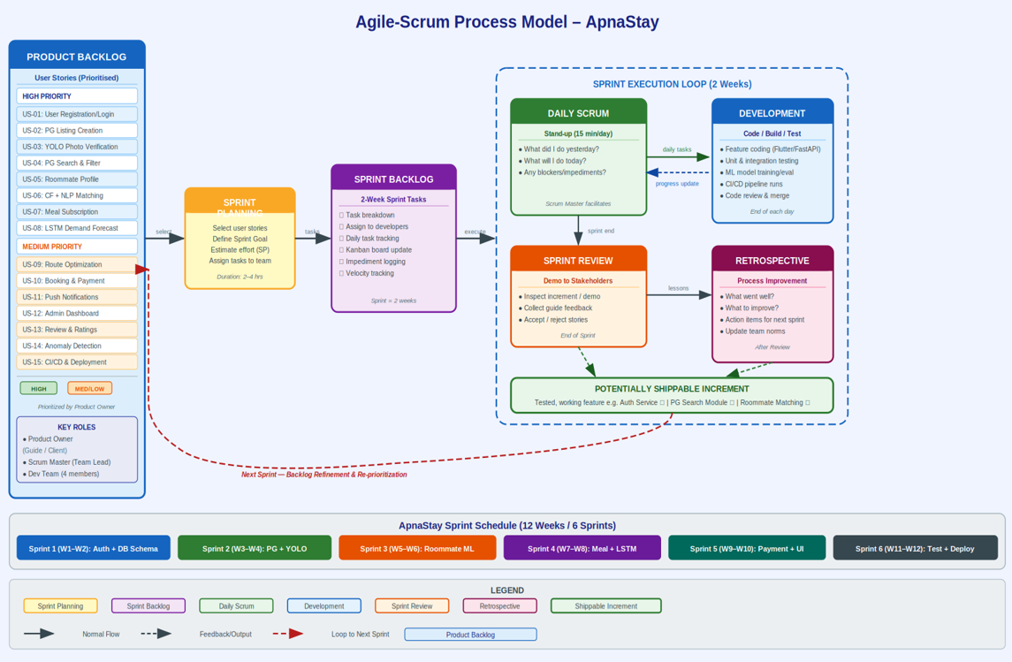

Figure 8.1: Agile – Scrum Process Model

Rationale for Agile-Scrum: (a) ML components such as the YOLO model and LSTM forecaster require iterative training and evaluation Agile accommodates changes in model performance without disrupting the development roadmap; (b) the three-module system (PG, Roommate, Meal) maps naturally onto six independent sprints; (c) frequent sprint reviews with the project guide ensure alignment; (d) daily standups keep the four-member team coordinated; and (e) retrospectives allow continuous improvement of both code quality and development practices.

Sprint | Duration | Goal / Deliverable | User Stories
Sprint 1 | Week 1–2 | Auth Service, DB Schema, User Profiles, JWT/RBAC | US-01, US-02 (partial)
Sprint 2 | Week 3–4 | PG Listing Module, YOLO Photo Verification, Geosearch | US-02, US-03, US-04
Sprint 3 | Week 5–6 | Roommate Profile, CF Engine, BERT NLP Matching | US-05, US-06
Sprint 4 | Week 7–8 | Meal Service, LSTM Forecasting, Route Optimization (A*) | US-07, US-08, US-09, US-14
Sprint 5 | Week 9–10 | Booking Module, RazorPay Integration, Flutter UI | US-10, US-11, US-13
Sprint 6 | Week 11–12 | Integration Testing, Admin Dashboard, CI/CD, Deployment | US-12, US-15

Table 8.1 : Weekly Sprint Table

8.2 Feasibility Study

The feasibility of the ApnaStay system is analyzed from three major perspectives:

8.2.1 Technical Feasibility

The system is technically feasible as it utilizes well-established and widely supported technologies such as Flutter, FastAPI, PostgreSQL, Firebase, and Machine Learning frameworks.

The integration of advanced technologies like:

YOLO for image verification

LSTM for demand forecasting

NLP for roommate matching

is achievable using existing libraries and tools. The development team has access to the required technical expertise, making the implementation practical and achievable.

8.2.2 Economic Feasibility

The project is economically feasible as it primarily relies on open-source technologies, reducing software licensing costs.

Costs involved include:

Cloud hosting and database services

API usage (Google Maps, RazorPay)

Maintenance and updates

Since the platform has potential for scalability and monetization (through bookings and subscriptions), the overall cost is justified and sustainable.

8.2.3 Operational Feasibility

The system is user-friendly and designed to meet the needs of students and working professionals relocating to new cities.

The mobile application provides:

Simple navigation

Easy search and booking features

Integrated services in one platform

Users do not require any special training, making the system operationally feasible. Additionally, admins can efficiently manage users, listings, and services through a centralized dashboard

8.3 Cost Analysis

The cost and effort for the ApnaStay system are estimated using the COCOMO (Constructive Cost Model). This model provides a technical validation of the project's complexity and helps justify the resource allocation required for a system involving multiple AI integrations.

8.3.2 Effort and Schedule Estimation

The estimation is based on a functional prototype size of approximately 5 KLOC (Kilo Lines of Code). This accounts for the development of high-complexity features including YOLOv8 for image verification, BERT-based NLP for roommate matching, and LSTM for meal demand forecasting.

Effort Calculation ($E$):

E = 2.4 * (KLOC)^ (1.05)

E = 2.4 * (5) ^ (1.05) = 13.04 Person-Months

This value represents the total volume of work required to build the system's logic and infrastructure.

Theoretical Development Time (D):

D = 2.5 * (E)^ (0.38)

D = 2.5 * (13.04) ^(0.38) = 6.6 (Months)

The COCOMO model provides this 6.6-month value based on a standard, sequential development process where tasks are completed one at a time.

Total Project Cost Formula (C)

The total cost is the sum of the labor value and the physical infrastructure expenses.

Labor Rate: ₹0

Infrastructure Costs: ₹2,000

Final Estimated Cost:

C = (13.04 x 0) + 2,000

Total Cost = ₹2,000

8.3.3 Timeline Compression Logic (Theoretical vs. Actual)

As illustrated in the estimation process, there is a strategic distinction between the theoretical model and the actual project execution:

Sequential vs. Parallel: The 6.6-month COCOMO value is a theoretical average assuming linear work. However, the actual 12-week (3-month) timeline is achieved by breaking the sequential chain.

Parallel Workstreams: While backend services are being developed, the frontend (Flutter) and machine learning modules are executed simultaneously.

Team Multiplier: By utilizing a three-person team working concurrently on distinct microservices, the 13.04 person-months of total effort is successfully compressed into a high-intensity 12-week cycle.

Agile Efficiency: Using 2-week sprints allows for rapid iteration and early resolution of integration issues between the API gateway and ML models.

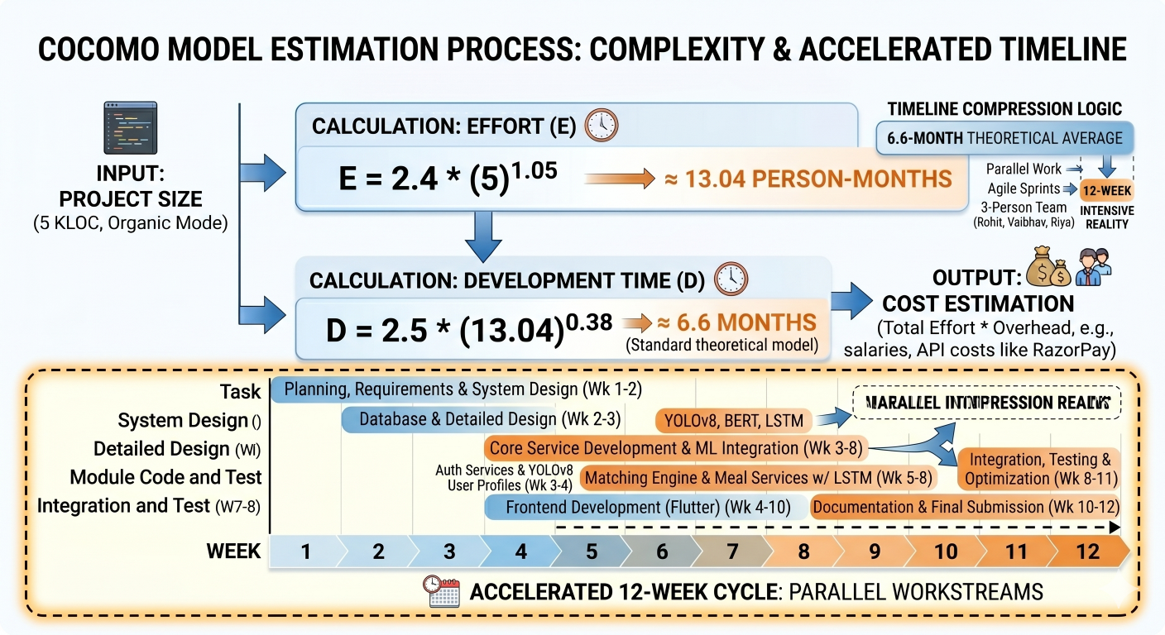

Figure 8.3.3: COCOMO Model Estimation Process and Accelerated 12-Week Timeline

8.3.4 Economic Feasibility

The project remains cost-effective by utilizing open-source frameworks such as Python, FastAPI, and Flutter to eliminate software licensing fees. Primary costs are allocated to cloud infrastructure (Firebase/PostgreSQL) and external API overheads for Google Maps and RazorPay integration.

8.4 Timeline Chart (For the Entire Project)

The development of the ApnaStay system is planned over a duration of 12 weeks, following an Agile-based approach with iterative development and continuous feedback.

The project is divided into the following phases:

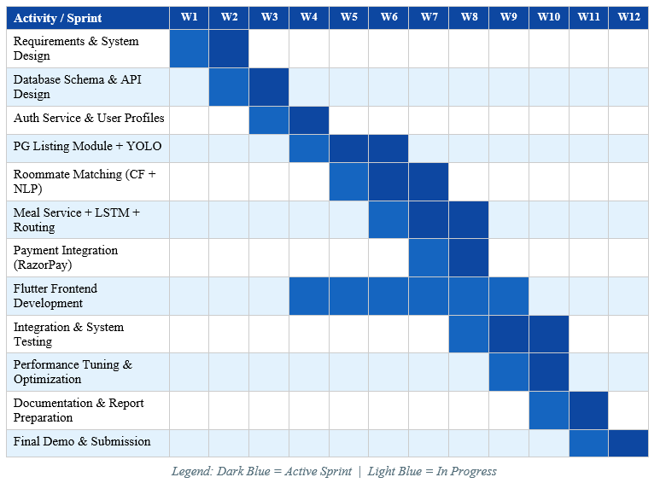

Figure 8.4: Timeline Diagram

DESIGN

9.1 Data Flow Diagrams

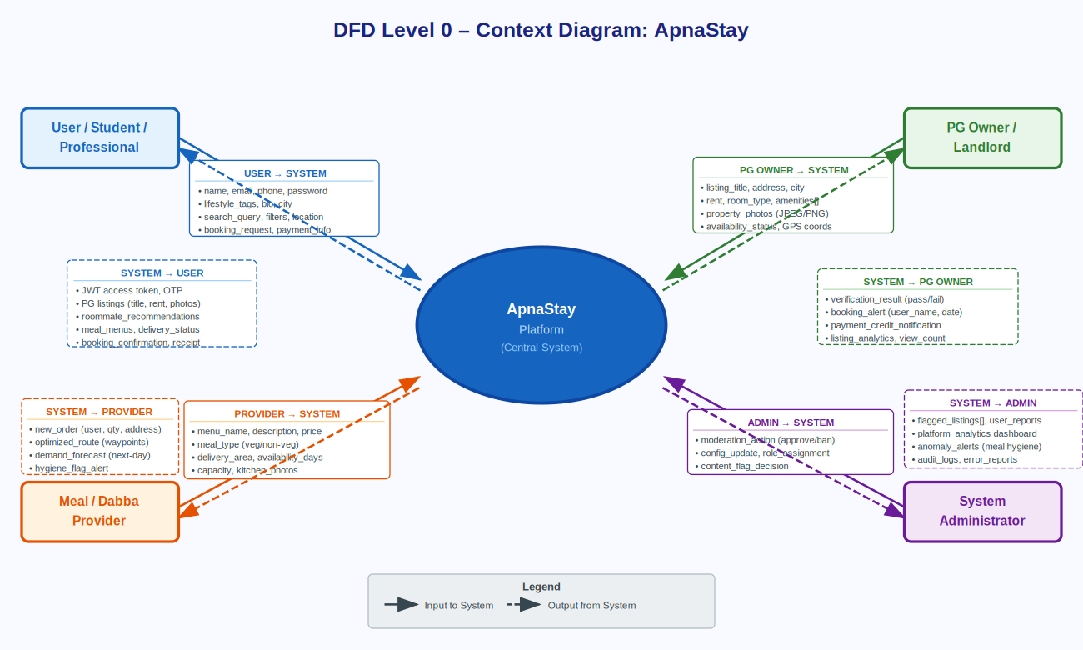

Fig.9.1: Data Flow Diagram – Level 0 (Context Diagram)

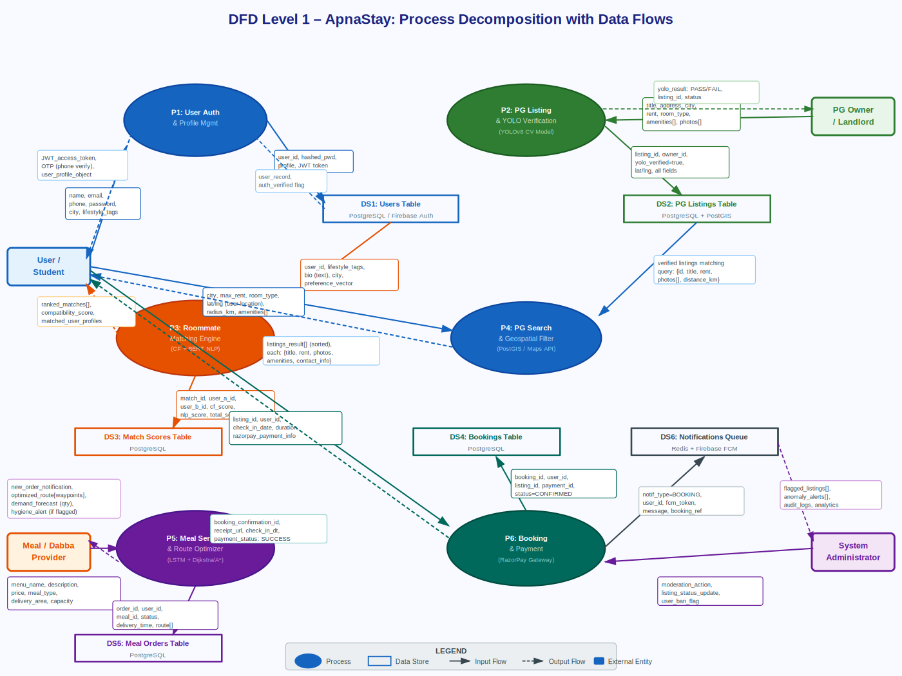

Fig.9.2: Data Flow Diagram – Level 1

9.2 UML Diagrams

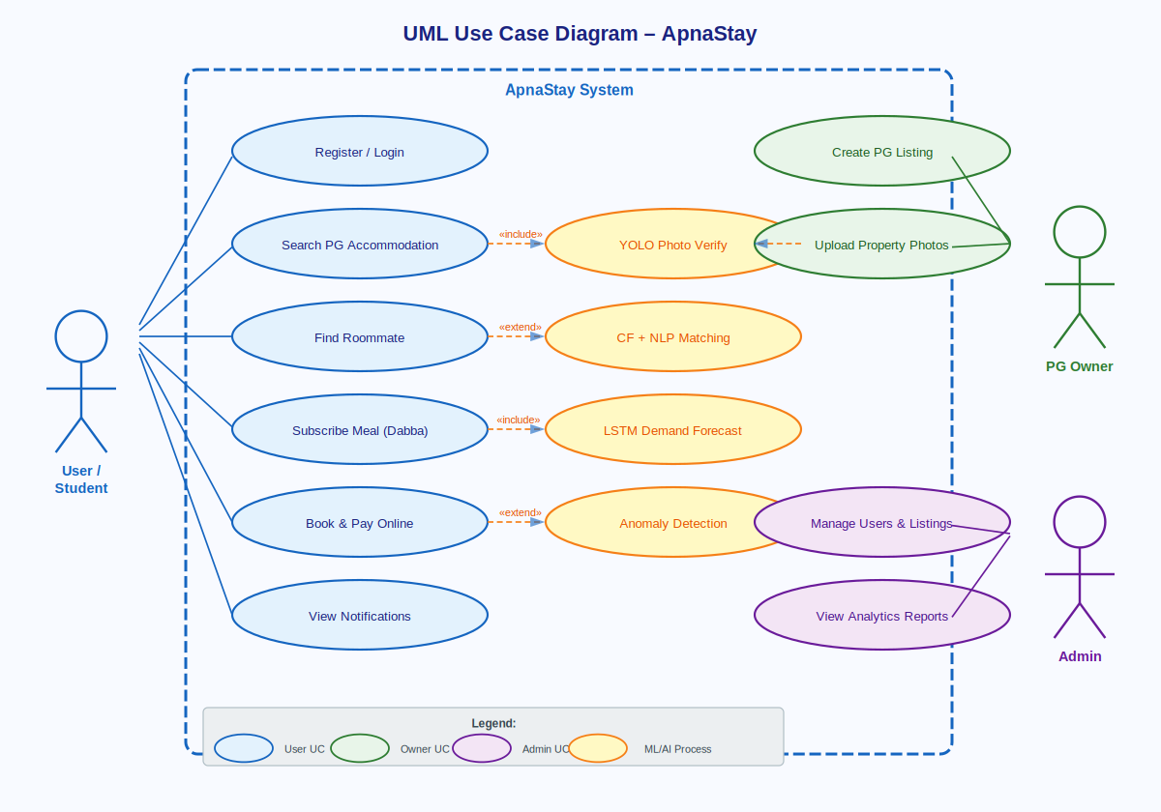

Fig.9.3: UML Use Case Diagram

9.3 EER Diagram

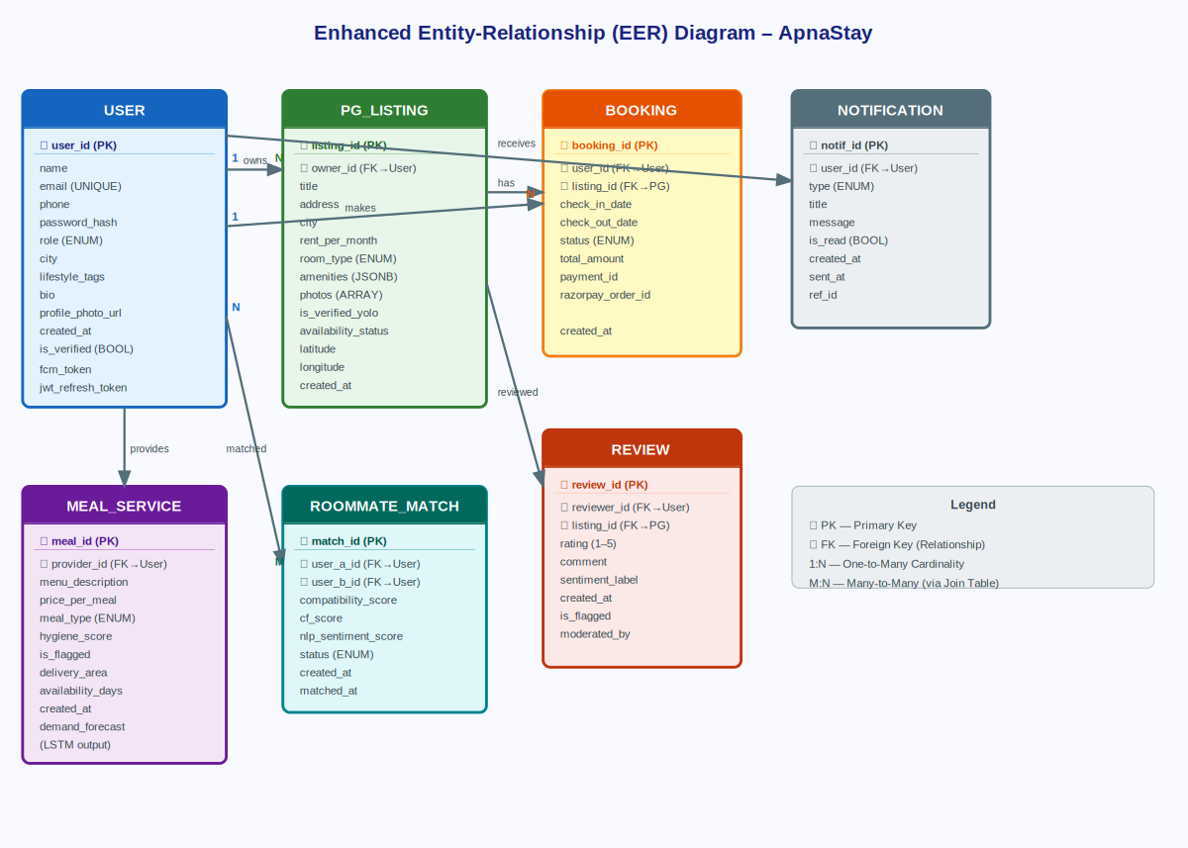

Fig.9.4: Enhanced Entity Relationship Diagram

9.4 Architecture Diagram

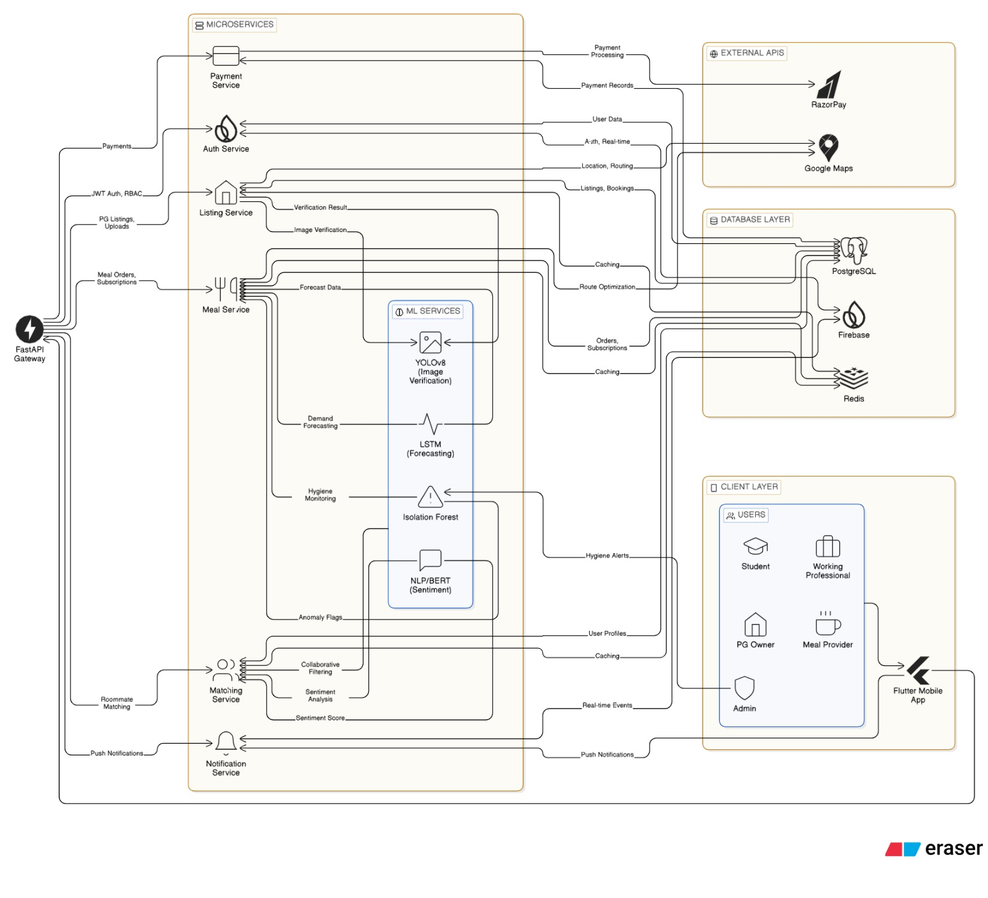

Fig.9.5: System Architecture Diagram

10. HARDWARE AND SOFTWARE REQUIREMENTS

10.1 Hardware Requirements

The development and deployment of the ApnaStay system require standard computing hardware capable of supporting mobile application development, backend services, and machine learning model execution.

The minimum hardware requirements are as follows:

Processor: Intel Core i5 or higher

RAM: Minimum 8 GB (16 GB recommended for ML processing)

Storage: Minimum 256 GB SSD

Device: Android/iOS smartphone for testing the mobile application

Internet Connectivity: Stable broadband connection for API integration and cloud services

These specifications are sufficient to handle development tasks such as coding, database management, API testing, and machine learning model training.

10.2 Software Requirements (Tech Stack)

The ApnaStay system is built using modern, scalable, and open-source technologies across different layers of the application:

Frontend

Flutter: Used for developing a cross-platform mobile application supporting both Android and iOS devices[10]

Dart: Programming language used in Flutter

Backend

FastAPI: High-performance Python framework used for building RESTful APIs[11]

Python: Core programming language for backend and ML integration

Database

PostgreSQL: Used for structured data storage (users, listings, bookings) [12]

Firebase: Used for authentication and real-time services [13]

Machine Learning & AI

TensorFlow / PyTorch: Frameworks used for building and training ML models [14][15]

YOLOv8: Used for image verification of PG listings [3][4]

NLP (BERT-based models): Used for roommate matching analysis [2]

LSTM: Used for demand forecasting [5][6]

APIs and Integrations

RazorPay: Payment gateway integration for secure transactions [16]

Google Maps API: Used for geolocation and route optimization [17]

Other Tools & Technologies

Redis: Used for caching and improving system performance

Git & GitHub: Version control and code management

Postman: API testing

Docker (optional): Containerization for deployment

REFERENCES

[1] F. Ricci, L. Rokach, and B. Shapira, Recommender Systems Handbook, 2nd ed. Springer, 2015.

[2] J. Devlin, M. Chang, K. Lee, and K. Toutanova, "BERT: Pre-training of Deep Bidirectional Transformers for Language Understanding," arXiv:1810.04805, 2018.

[3] J. Redmon, S. Divvala, R. Girshick, and A. Farhadi, "You Only Look Once: Unified, Real-Time Object Detection," IEEE CVPR, 2016.

[4] G. Jocher et al., "Ultralytics YOLOv8," GitHub, 2023. Available: https://github.com/ultralytics/ultralytics

[5] S. Hochreiter and J. Schmidhuber, "Long Short-Term Memory," Neural Computation, vol. 9, no. 8, pp. 1735–1780, 1997.

[6] A. Graves, "Supervised Sequence Labelling with Recurrent Neural Networks," Studies in Computational Intelligence, Springer, 2012.

[7] F. T. Liu, K. M. Ting, and Z. H. Zhou, "Isolation Forest," IEEE ICDM, pp. 413–422, 2008.

For Route Optimization — Dijkstra & A* (Chapter 6, 7)

[8] E. W. Dijkstra, "A Note on Two Problems in Connexion with Graphs," Numerische Mathematik, vol. 1, pp. 269–271, 1959.

[9] P. E. Hart, N. J. Nilsson, and B. Raphael, "A Formal Basis for the Heuristic Determination of Minimum Cost Paths," IEEE Transactions on Systems Science and Cybernetics, vol. 4, no. 2, pp. 100–107, 1968.

[10] Flutter Team, "Flutter Documentation," Google, 2024. Available: https://flutter.dev/docs

[11] S. Ramírez, "FastAPI Framework," 2024. Available: https://fastapi.tiangolo.com

[12] PostgreSQL Global Development Group, "PostgreSQL 16 Documentation," 2024. Available: https://www.postgresql.org/docs

[13] Google, "Firebase Documentation," 2024. Available: https://firebase.google.com/docs

[14] TensorFlow Team, "TensorFlow Documentation," Google, 2024. Available: https://www.tensorflow.org

[15] PyTorch Team, "PyTorch Documentation," Meta AI, 2024. Available: https://pytorch.org

[16] Razorpay, "Razorpay API Documentation," 2024. Available: https://razorpay.com/docs

[17] Google, "Google Maps Platform Documentation," 2024. Available: https://developers.google.com/maps

